Smart Algae Panel System
Project: Analyzing the Effects of Smart Algae (Chlorophyta) Panels for Thermal Heat Index Reduction

1. System Overview
This system measures:
• CO2 concentration
• Temperature
• Humidity
• Raw pH sensor signal
The Arduino collects RAW data only. All analysis must be done externally.

2. Install Arduino IDE
1. Go to this link Arduino or click this direct link.
2. Download Arduino IDE
3. Install using default settings
4. Launch Arduino IDE after installation

3. Connect the Arduino
1. Plug Arduino Uno into computer using USB cable
2. Open Arduino IDE
3. Go to Tools → Board → Arduino Uno
4. Go to Tools → Port → Select the COM port that appears

4. Install Required Libraries
In Arduino IDE:
1. Click Sketch → Include Library → Manage Libraries
2. Search and install:
• SparkFun SCD4x Arduino Library
• LiquidCrystal I2C by Frank de Brabander

5. Wiring Instructions
SCD40 Sensor:
VIN → Arduino 3.3V
GND → Arduino GND
SDA → Arduino A4
SCL → Arduino A5
I2C LCD:
VCC → Arduino 5V
GND → Arduino GND
SDA → Arduino A4
SCL → Arduino A5
pH Sensor Module:
V+ → Arduino 5V
G → Arduino GND
Po → Arduino A0
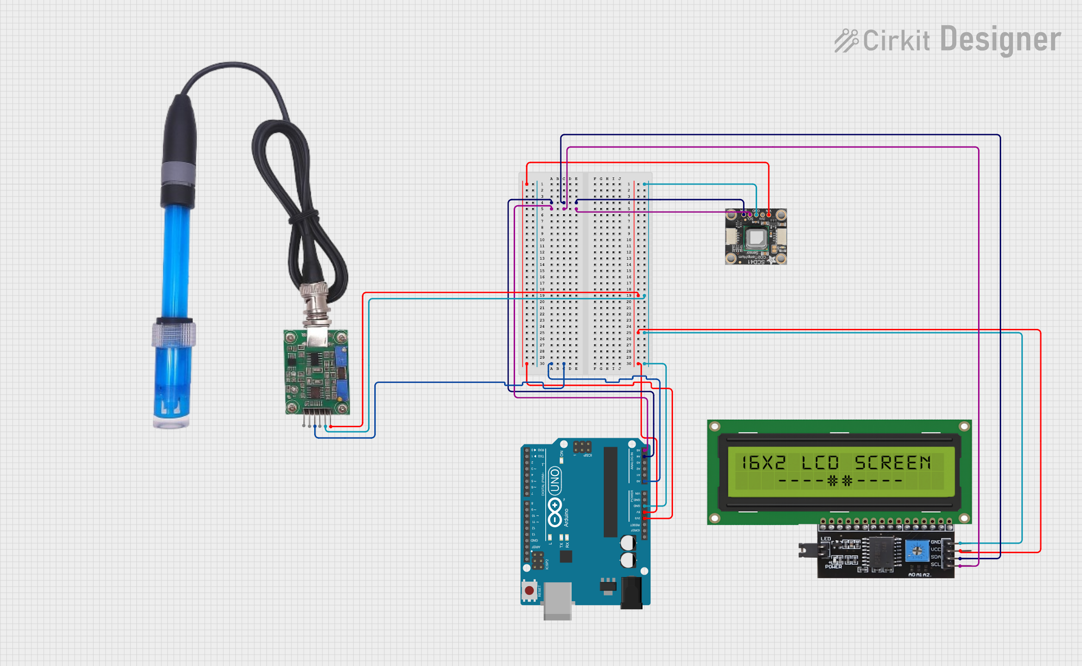
Smart Algae Panel Wiring Diagram shows the complete physical connections between the Arduino Uno, SCD40 sensor, I2C LCD, and pH module.

6. Upload the Firmware
1. Open the Smart Algae firmware (.ino file) (Go to File → Open→ SmartAlgaePanel.ino)
2. Click Verify (✓)
3. Wait for 'Done compiling'
4. Click Upload (→)
5. Wait for 'Done uploading'

7. First Startup
After upload:
• LCD shows splash screen
• Title scroll appears
• Sensor initializes
• Live readings begin

8. Viewing Data
To view readings on computer:
1. Open Serial Monitor
2. Set baud rate to 9600
3. Observe data lines for CO2, temperature, humidity, and pH RAW

9. Proper Handling of Sensors
SCD40:
• Do not cover holes
• Avoid water splashes
pH Probe:
• Fragile glass tip
• Do not drop
• Keep slightly moist if stored
Wiring:
• Do not unplug while powered

10. Troubleshooting
LCD blank:
• Check wiring
• Adjust LCD contrast screw
Upload fails:
• Check correct COM port
• Check USB cable
Sensor error:
• Restart Arduino
• Check sensor wiring

11. Shutdown Procedure
1. Close Serial Monitor
2. Unplug USB cable safely
3. Store sensors properly

